Project Weekly Progress Report  
Agile – Scrum

|  |  |
| --- | --- |
| Semester | Fall-2024 |
| Course Code | AML2404 |
| Section | Section 2 |
| Group Name | Group 4 |
| Student names/Student IDs | Meher Vamsi Dontoju - C0893004​  Rudraksh Bahri - C0891302​  Sarveswararao Patchipulusu - C0892924​  Tazeen Singh Sudan - C0891287 |
| Reporting Week | Week - 2 |
| Team Lead for the reporting week | Rudraksh Bahri |

PROJECT PROPOSAL

Introduction:

In an era where technology and automation are revolutionizing the way businesses operate, the restaurant industry is no exception. Restaurants are increasingly turning to chatbots to enhance customer service, streamline operations, and provide a more personalized dining experience. This document provides a comprehensive overview of the key components and steps involved in building a restaurant chatbot.

Abstract/Summary:

The proposed project aims to create an advanced restaurant chatbot that enhances the dining experience for customers and streamlines restaurant operations. This chatbot will assist customers with reservations, menu inquiries, order placement, and customer support. It leverages natural language processing (NLP) and artificial intelligence (AI) to provide personalized recommendations and sentiment analysis. By integrating with WhatsApp for social media interaction, the chatbot offers a comprehensive solution to enhance the restaurant experience.

Statement of Need:

The restaurant industry faces increasing demands for streamlined operations and improved customer engagement. The proposed chatbot addresses these needs by providing a versatile and efficient tool for handling reservations, orders, inquiries, and feedback. Customers benefit from enhanced convenience, while the restaurant gains operational efficiency and valuable customer insights.

Project Activities, Methodologies, and Outcomes:

Defining Objectives:

* Before embarking on the journey to create a restaurant chatbot, it is essential to define clear objectives. The primary goals could include but are not limited to:
* Ordering and Reservations: Facilitate online ordering and table reservations.
* Information Dispensation: Provide menu details, operating hours, location, and answers to frequently asked questions (FAQs).
* Promotions and Specials: Promote daily specials, discounts, and events to attract customers.
* Customer Engagement: Engage customers through social media platforms like WhatsApp.
* Analytics and Feedback: Gather insights through analytics and collect feedback to improve services.

Project Activities:

* Develop a chatbot capable of handling reservations, menu inquiries, and order placement.
* Integrate the chatbot with WhatsApp for social media interaction.
* Implement recommendation engines and sentiment analysis for personalized customer experiences.
* Design a user-friendly web interface using HTML, CSS, and JavaScript.
* Utilize MongoDB/MySQL for data storage, including menu data, reservations, and customer feedback.
* Deploy the chatbot on Microsoft Azure for scalability and reliability.

Expected Outcomes:

* A functional restaurant chatbot capable of assisting customers with various tasks.
* Improved customer engagement and convenience.
* Streamlined restaurant operations, including reservations and order processing.
* Valuable insights through sentiment analysis and customer feedback.
* Enhanced online payment processing for takeout orders.

Project Timeline:

Week 1-2: Requirement gathering and design.

Week 3-8: Development and integration.

Week 9-10: Testing and optimization.

Week 11-12: Deployment and launch.

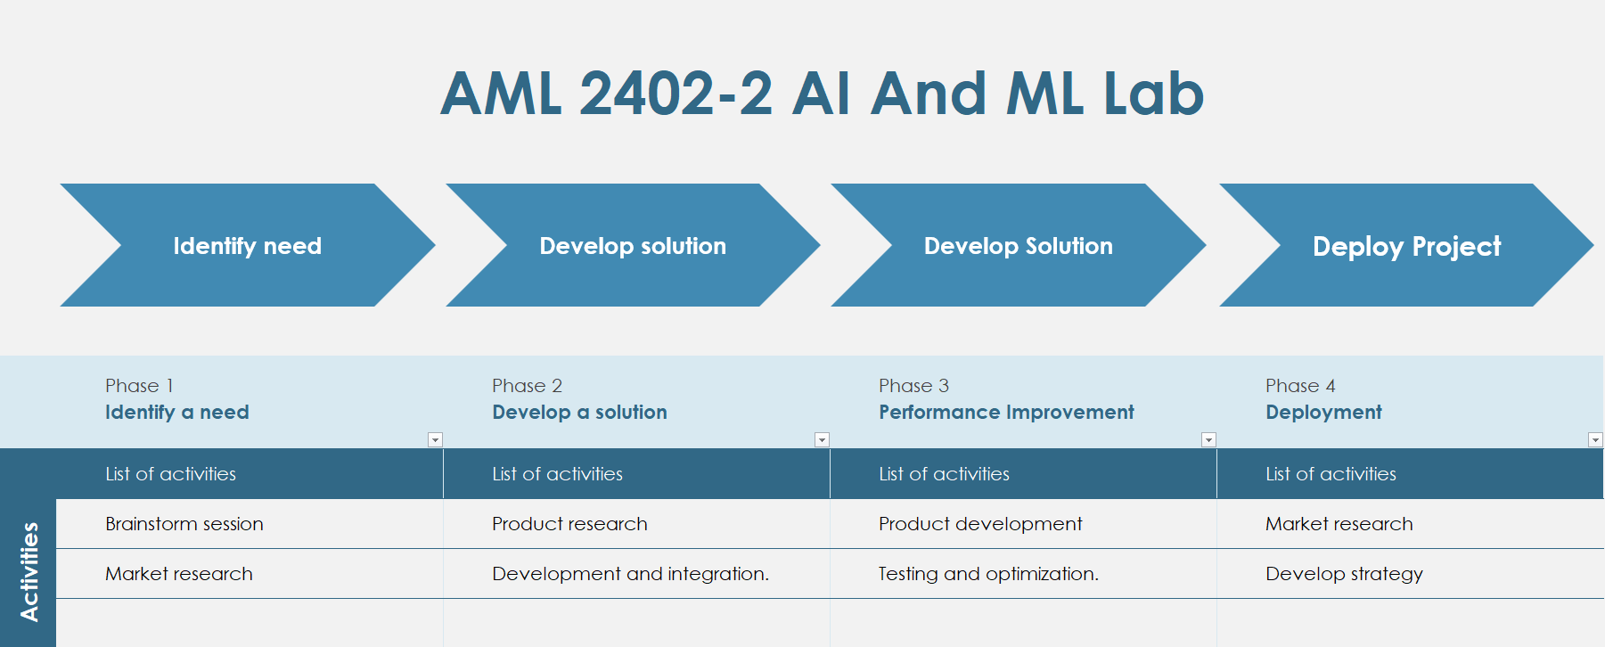

Fig 1: Project Timeline

Key Components:

1. Programming Languages:

Python: For chatbot development, NLP tasks, and machine learning.

1. Natural Language Processing (NLP):

NLTK (Natural Language Toolkit): For NLP tasks such as text tokenization and sentiment analysis.

1. Chatbot Framework:

Dialogflow: A user-friendly chatbot development platform by Google, offering NLP capabilities.

(or)

Microsoft BOT Framework: A comprehensive framework for building conversational AI experiences.

1. User Interface:

HTML/CSS: For designing a responsive and user-friendly web interface.

JavaScript: For front-end interactivity and dynamic content.

1. Database:

MongoDB/MySQL: To store menu data, reservations, customer feedback, and chatbot interactions.

1. Cloud Services:

Azure: To host the chatbot and ensure scalability and reliability.

1. Machine Learning Libraries:

Scikit-Learn: For building recommendation engines and conducting sentiment analysis.

1. Analytics:

Google Analytics: To track user interactions, website performance, and customer behavior.

1. Development Tools:

Visual Studio Code (VSCode): As the primary code editor.

GitHub: For version control and collaboration.

Roles and Responsibilities:

|  |  |  |
| --- | --- | --- |
| Name | Student No. | Tasks & Responsibilities |
| Meher Vamsi Dontoju | C0893004 | Database Management, Azure Hosting, User Interface, Utilization of ML Techniques |
| Rudraksh Bahri | C0891302 | Analytics, Backend development, Utilization of ML Techniques |
| Sarveswararao Patchipulusu | C0892924 | Chatbot Framework, Backend development |
| Tazeen Singh Sudan | C0891287 | Model Implementation, Backend development |

Conclusion:

Building a restaurant chatbot is a complex but rewarding endeavor. By defining clear objectives, integrating the right components, and focusing on user experience, a restaurant chatbot can enhance customer engagement, streamline operations, and provide valuable insights for continuous improvement. Embracing technology in the restaurant industry through chatbots is a step toward the future, offering customers a more convenient and enjoyable dining experience.

PROGRESS MADE IN WEEK 2:

Our team made considerable progress in Week 2. We have decided on our capstone project. We have developed a project timeline and gathered information about the requirements. A proposal has been made, attached above to this document.

The proposal started with an abstract that described the chatbot's goals and its integration with WhatsApp for social media interaction. The statement of need emphasized the industry's desire for increased consumer involvement and efficient processes.

The project activities were meticulously planned, beginning with specific goals such as handling bookings, menu questions, and promotions. The project's key components included Python programming languages, NLP tools like NLTK, chatbot frameworks, HTML/CSS and JavaScript user interface development, database management, cloud hosting, machine learning libraries, and analytics with Google Analytics.

A complete project timetable covering requirement gathering, development, testing, and deployment was supplied. The project's expected goals included a functional chatbot, more customer engagement, simpler restaurant operations, useful insights gained through sentiment analysis and feedback, and improved online payment processing.

To demonstrate the project's technological tools, key tools and development resources such as Visual Studio Code and GitHub were also highlighted.

CHALLENGES FACED IN WEEK 2:

The following are the challenges that we faced during defining the project proposal, after selection of our project:

1. Understanding Project Requirements: Understanding the project's precise requirements and expectations was a bit difficult, we had difficulty in determining what exactly needs to be included.
2. Scope Definition: Defining the scope of the project and ensuring that it is practical and feasible within the available timeframe was difficult for us.
3. Gathering Relevant Information and completing comprehensive Research: Gathering relevant information and completing comprehensive research to support the idea was time-consuming. Finding reputable sources was not easy and finding a relevant dataset was difficult.
4. Technical specifics: The project requires technical features such as programming, data analysis, etc., for which many technologies and resource options are available, and choosing the correct ones is a task.

REFERENCES:

[1] Stephanie (2020, July 30). Top 7 requirements for chatbot software. *ONLIM.* <https://onlim.com/en/top-requirements-for-chatbot-software/>

[2] Daryna L. (2022, December 1). Chatbot requirements Technical & Non-Technical to consider. *BotsCrew.* <https://botscrew.com/blog/essential-chatbot-requirements/>

[3] Ivy.ai. A Guide for developing AI Chatbots for Higher Education. *Ivy* <https://go.ivy.ai/hubfs/Marketing/Handouts%20and%201%20Pagers/Example%20AI%20%20Chatbot%20Requirements.pdf>

[4] Steven B., Ewan K., and Edward L. (2009). Natural Language Processing with Python. *O’Reilly Media Inc.* <https://www.nltk.org/book/>

[5] Python/C API Reference Manual. Python Software Foundation. <https://docs.python.org/3/c-api/index.html>